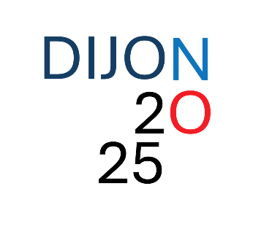
Presentation Guidelines

Poster presentations
- Poster dimensions: A0 size in portrait orientation.
- Poster flash talks (optional): The poster flash talks are meant to be very brief (1-2 minutes maximum, using only 1 slide). Focus on delivering your key message to encourage attendees to visit your poster during the breaks.
Short talks
- Short talks will be selected from submitted abstracts, depending on the number of participants.

For both poster and short talks presentations, please follow the abstract template provided below (in Word format) and submit it to:
meeting-organizers-dijon@u-bourgogne.fr

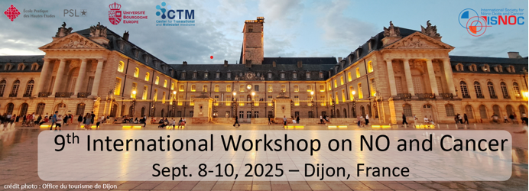
Title

Authors (underlined the presenter)

Affiliations

Abstract (max 500 words)

Key words (3-5)
Preferred conference type:
- Poster
- Poster + flash oral presentation
- Short talk

